**CPSC531-01 Advanced RDBMS**

**Project Proposal**

**CERULEAN BEE**

**By: Group DB-13**

**Himani Tawade (CWID: 885942128)**

**Smit Trambadia (CWID: 885941500)**

**CPSC 531-03(22474)**

**Spring, 2022**

**Professor: Dr. Chun-l Phillip Chen**

**Department of Computer Science**

**California State University, Fullerton**

**March 2022**

**Table of Contents**

**ABSTRACT** 4

**1.0 Introduction** 5

1.1 Background 5

1.2 Project Goals and Benefits 9

1.3 Relevance and Significance 9

1.4 Assumptions and Limitations 9

**2.0 Project Requirements** 10

2.1 Data requirements 10

2.1.1 Conceptual Model (ER Model) 10

2.1.2 Logical Data Model (Database Normalization) 11

2.2 Functional Requirements (Business functions, Input, and Output Layouts) 16

2.2.1 Interface Requirements 16

2.2.2 Business Requirements 19

**3.0 Methodology** 20

3.1 DDL Commands 20

3.2 Software Stack 24

3.2.1 Database: 24

3.2.2 Programming Language: 24

3.2.3 Software: 24

**4.0 Results and Discussion** 24

4.1 Screens 25

**5.0 Conclusions** 31

5.1 Significance 31

5.2 Learnings from this project 31

5.3 Future Work 31

**6.0 Appendices** 32

**List of Figures**

*Artwork Order* 5

*Employee Work Log* 6

*Print Order* 7

*Project Cost Analysis* 8

*ER Diagram* 10

*Logical Data Model* 15

*Art Table* 20

*Customer Table* 20

*Employee Table* 21

*Inovice Table* 21

*Material Table* 21

*Labour Table* 22

*Order Date Table.* 22

*Order Details Table* 22

*Print Order Table* 23

*Project Table* 23

*Revenue Table* 23

*Login Screen* 25

*Signup Screen* 25

*Dashboard Screen* 26

*Artwork Order Screen* 26

*Add Artwork Order Screen* 27

*Employee Work Log Screen* 27

*Add Employee Work Log Screen* 28

*Print Order Screen* 28

*Add Print Order Screen* 29

*Project Cost Analysis Screen* 29

*Add Project Cost Analysis Screen* 30

# **ABSTRACT**

Cerulean Bee is a small company whose product is customized apparels. The main target audience

For this company are local clubs who want customized T-shirts, Jerseys and other apparels which they either sell or give to everyone who registers.

Artwork orders are placed by customers either individually or by an organization. Sometimes customers come with either a vague idea of the artwork they need on attire or computer-printed designs. In most cases, the artist must clean up the artwork reasonably well on the desired item. The art must be color separated so that color has its film. The final product should have color separation, so the colors don't overlap, and the separate layers align separately.

As location of each design can be different it needs a separate pass through the print process as each color requires a different film and a distinct imprint, for achieving this each print will require a different setup. And due to this, customers are charged by the number of artwork elements and the number of colors included. The total price of the artwork generally consists of a setup and per-item charges.

Organizations order items in bulk with the same print, so sometimes, organizations are given a discount. But these discounts are unpredictable and decided by Bob. Most customers provide orders to create attire associated with some event, for example, festival, party, and bike ride. It's the artist's responsibility to work on a design according to the event theme.

# **1.0 Introduction**

1.1 Background

Bob's sales report is the focus of this effort. The main focus of this project is on Bob Bee, an artist who owns a firm that designs and prints t-shirts and jerseys. The purpose of this database project is enabling Bob Bee's management to monitor personnel logs, print orders, project cost evaluations, and artwork orders. SQLITE is used to implement the project. These projects are on database creation and management technology. This project makes it simple to organize all CRUD processes.

The project's key feature is that it maintains all of the information about staff and clients, including the artwork they need computer printed. There would be four major players. They are as follows:

1. Artwork: It will hold information about clients such as their name, contact information, phone number, orders, the date their order was accepted, the sort of item they require, the quantity required, and the color required. And the employee's information, such as the completion date, which employee is working on that item, and how much they are paid.

**Artwork_order**

**Customer**

customer_id, customer_name, contact, phone, discount, total_price,

order_date, date_approval, scheduled_print_date, event, theme, apparel_item,

base_colors, max_colors

**Art**

art_location, art_description, art_cost, employee_name, date_complete, art_colors

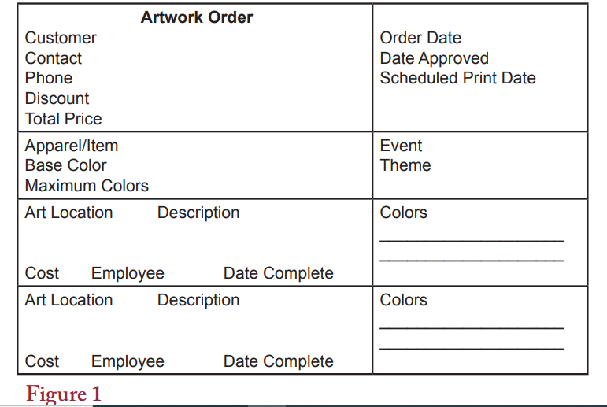

1. 2. An employee work log: An employee work log keeps track of which employee is allocated to which task, which person is working on which project for how long, whether the employee is full-time or part-time, and what they are using in the art, as employees are paid based on their time logs.

**Employee works log:**

**Employee**

employee_id, employee_name, employee_phone, job_type, job_date, start_time,

employee_work_time

**Project**

Project_id, project_description, art_item, task

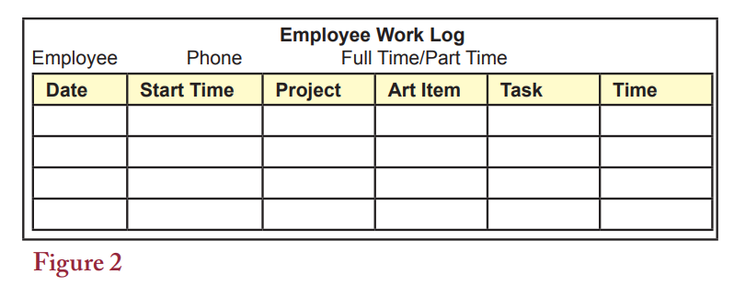

1. Print Order: This diagram shows the customer's information as well as the art item or colors utilized for the items. It will keep track of both the order and delivery dates. It would also keep track of how much money was collected as a deposit and how much money was left over. It will also display the pricing per unit of an item, as well as the size of the item required and the colors to be utilized for the order. It will display all of the charges for the item, including color, delivery, and other fees. It would be similar to the product's invoice.

**Print order**

**customer**

customer_id, customer_name, contact, phone, email, setup_charge, deposit, discount, total_cost, order_date, due_date, apparel_order_date, art_film_date, print_date, delivered_date

**apparel_item**

base color, vendor_name, item_size, item_number, item_additional_charges, per_unit_base_price, item_color_charge, total_blank_price

**art_details**

art_print, art_location, art_size, art_color_charge, art_slide_date, total_color_list

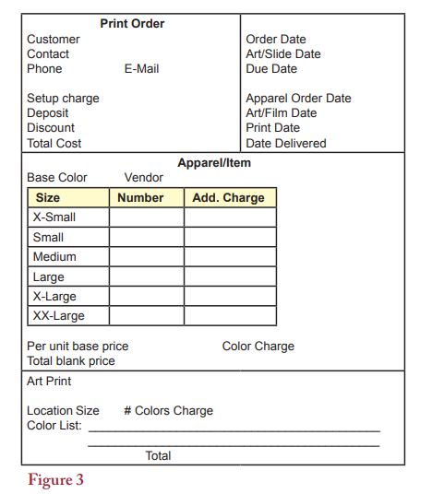

1. Project Cost Analysis: Only the admin will see this figure because it saves the value of how much profit the company made from each project. How many items were used, and how much did each item cost per unit? It will also specify how much time staff devote to each project and how they are compensated.

**Project_cost_analysis**

**Project**

project_id, project_name, event, toal_item, customer_id, customer_name, order_date, delivered_date

**Material_cost**

mat_item, mat_per_unit_cost, price_charged, unit_buy, mat_cost, total_mat_cost, mat_revenue, total_mat_revenue

**Labour_costs**

employee_id, employee_name, task_id, time, wage_rate, cost, total_labour_cost

**Total_revenue**

total_money_recevied, total_mat_charge, total_artwork_fees, fixed_charge, total_mat_cost, total_labour_cost, shipping_cost, discounts, project_net_profit

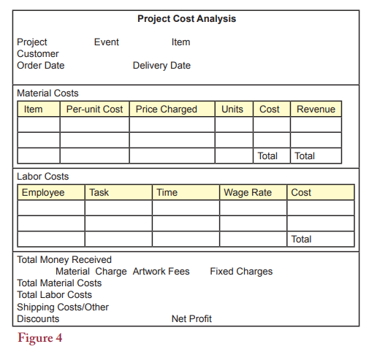

At the end of each project, Bob creates a report that includes a cost analysis for each recent endeavor. This data was utilized to help establish prices and determine which jobs increase profits. He starts with the net profit data and then moves on to the subtotal breakdown. He only examines the material and labor expenses in circumstances that appear unique.

The normalization of databases was also discussed in this research. We also used the ER model to highlight the relationship between the tables. We also included functional requirements such as business functions, input and output layouts at the end of this project proposal.

1.2 Project Goals and Benefits

• The business owner receives a system that he may use to analyze customer orders and determine whether the company has generated a profit or loss.

•The employee can submit their work logs as well as the project specifics on which they are currently working.

• The customer can place their own order based on their preferences as well as the theme or event style. They can also add color and artwork to their jerseys or shirts as needed.

1.3 Relevance and Significance

1. Gained experience with table normalization and database implementation.

2. Discovered how to make tables for certain purposes.

3. Acquired knowledge of relational databases, such as Sqlite.

4. Acquired real-world experience with databases.

5. To improve an e-commerce website's cost analysis, it's critical to create a database and save all necessary data on staff and apparel.

1.4 Assumptions and Limitations

**Assumptions:**

• The employee can also see, edit, delete, and add client and artwork details. They must also record their labor in accordance with their project and artwork. They must be logged into their portal to do so.

• Customers should be able to register, place orders, and track their orders through the online application.

• Only the app's owner has access to creating, updating, and removing different clients, orders, and workers.

• We presume that only the admin, or the owner of the program, may see, change, and delete the material cost, per unit cost, price charged, and income.

**Limitations:**

# • There is no analysis system that can tell BOB what type of consumer is coming to the organization in terms of preferences, likes, dislikes, and so on.

# • There is no database for the warehouse to use to determine if a product is in stock or not.

# • Because the buyer only sees the image of the artwork during the ordering process, the final product may change from what was shown during the purchase process.

# **2.0 Project Requirements**

2.1 Data requirements

2.1.1 Conceptual Model (ER Model)

We present all of the different entities and their relationships in the ER model for this project. We indicate the cardinality of the link between entities and provide all additional attributes used for the corresponding entities.

The ER diagram is as follows.

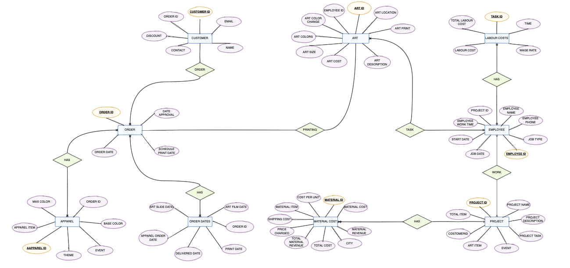

2.1.2 Logical Data Model (Database Normalization)

**Datebase 1:**

**Artwork_order** : customer_name, contact, phone, discount, total_price, order_date, date_approved, scheduled_print_date, event, theme, apparel_item, base_colors, max_colors, art_location, art_description, art_cost, employee_name, date_complete, art_colors)

**1NF:**

**Customer** (customer_id, art_id, customer_name, contact, phone, discount, total_price, order_id)

**Order_Details**( customer_id, order_id ,order_date, date_approval, scheduled_print_date, theme, apparel_id)

**Art** (art_id, art_location, art_description, art_cost, employee_id , date_complete, art_colors, art_print, art_size, art_color_charge)

**2NF:**

**Customer** (customer_id, art_id, customer_name, contact, phone, discount, total_price, order_id)

**Order_Details**( customer_id, order_id ,order_date, date_approval, scheduled_print_date, theme,apparel_id)

**Art** (art_id, art_location, art_description, art_cost, employee_id , date_complete, art_colors, art_print, art_size, art_color_charge)

**3NF:**

**Customer** (**customer_id**, art_id, customer_name, contact, phone, discount, total_price, order_id)

**Order_Details**( customer_id, order_id ,order_date, date_approval, scheduled_print_date, theme,apparel_id)

**Art** (**art_id**, art_location, art_description, art_cost, employee_id , date_complete, art_colors, art_print, art_size, art_color_charge)

**Employee_work_log** (**employee_id**, employee_name, phone, job_type, job_date, start_time, project_id, project_description, art_item, task_id, time)

**Database 2:**

**1NF:**

**Employee** (**employee_id,** employee_name, employee_phone, job_type, job_date, start_time, employee_time, project_id)

**Project** (**project_id,** project_description, art_items, task_id , project_name, event, total_item, customer_id, order_date, delivered_date)

**2NF:**

**Employee** (**employee_id**, employee_name, employee_phone, job_type, job_date, start_time, employee_time, project_id)

**Project** (**project_id**, project_description, art_items, task_id , project_name, event, total_item, customer_id, order_date, delivered_date)

**3NF:**

**Employee** (**employee_id**, employee_name, employee_phone, job_type, job_date, start_time, employee_time, project_id)

**Project** (**project_id,** project_description, art_items, task_id , project_name, event, total_item, customer_id, order_date, delivered_date)

**Print_order** (**customer_id**, customer_name, contact, phone, email, setup_charge, deposit, discount, total_cost, order_date, art_slide_date, due_date, apparel_order_date, art_film_date, print_date, delivered_date)

**apparel_item** (**apparel_id,** order_id, base_color, vendor_name, item_size, item_number, item_additional_charges, per_unit_base_price, item_color_charge, total_blank_price, art_print, art_location, art_size, art_color_charge, total_color_list, total_price)

**Database 3:**

**1 NF:**

**Print_order** (**customer_id**, customer_name, contact, phone, email, setup_charge, deposit, discount, total_cost, order_date, art_slide_date, due_date, apparel_order_date, art_film_date, print_date, delivered_date, item_id, art_print, art_location, art_size, art_color_charge, total_color_list)

**Apparel_item** (**apparel_id**, order_id, base_color, vendor_name, item_id, item_size, item_number, item_additional_charges, per_unit_base_price, item_color_charge, total_blank_price)

**2 NF:**

**Print_order** (**print_customer_id**, setup_charge, invoice_id, art_slide_date, apparel_order_date, art_film_date, print_date, delivered_date, item_id, art_id, total_color_list)

**Invoice** (**invoice_id**, deposit, discount, total_cost, order_date, due_date)

**Apparel_item** (**apparel_id**, order_id, base_color, vendor_name, item_id, item_size, item_number, item_additional_charges, per_unit_base_price, item_color_charge, total_blank_price)

**3 NF:**

**Print_order** (**customer_id**, setup_charge, invoice_id, item_id, art_id, total_color_list)

**Order_date** (**order_id**, art_slide_date, apparel_order_date, art_film_date, print_date, delivered_date)

**Invoice** (**invoice_id,** deposit, discount, total_cost, order_date, due_date)

**Apparel_item** (**apparel_id**,base_color, vendor_name, item_id, item_size, item_number, item_additional_charges, per_unit_base_price, item_color_charge, total_blank_price)

**Datebase 4:**

**1NF:**

**Project** (**project_id,** project_name, event, total_item, customer_id, order_date, delivered_date)

**Material_cost** (**material_id**, material_item**,** material_per_unit_cost, price_charged, unit_no, material _cost, total_ material _cost, material _revenue, total_ material _revenue)

**Labour_costs** (**employee_id**, task_id, time, wage_rate, cost, total_labour_cost)

**Total_revenue** (**revenue_id**, order_id, total_money_recevied, total_mat_charge, total_artwork_fees, fixed_charge, total_mat_cost, total_labour_cost, shipping_cost, discounts, project_net_profit)

**2NF:**

**Project** (**project_id**, project_name, event, toal_item, customer_id,)

**Material_cost** (**material_id**, material_item, material _per_unit_cost, price_charged, unit_no, material _cost, total_ material _cost, material _revenue, total_ material _revenue)

**Labour_costs** (**employee_id,** task_id, time, wage_rate, cost, total_labour_cost)

**Total_revenue** **(revenue_id**, total_money_recevied, total_material_charge, total_artwork_fees, fixed_charge, total_mat_cost, total_labour_cost, shipping_cost, discounts, project_net_profit)

**3NF:**

**Project** (**project_id**, project_name, event, toal_item, customer_id)

**Material_cost** (**material_id**, material_item, material _per_unit_cost, price_charged, unit_no, material _cost, total_ material _cost, material _revenue, total_ material _revenue)

**Labour_costs** (**employee_id** , task_id, time, wage_rate, cost, total_labour_cost)

**Total_revenue** (**revenue_id**, order_id, total_money_recevied, total_material_charge, total_artwork_fees, fixed_charge, total_mat_cost, total_labour_cost, shipping_cost, discounts, project_net_profit)

**To identify fields with unique values:**

A unique value is required to combine tables with data contained in different tables. To link other tables, each table should have its own identity. The primary key is a set bridge like this. There is a primary key, a foreign key, and numerous primary key fields in this database.

**For example:**

The primary key attribute for the table art details is ART ID, and the table also has a foreign key called EMP ID, which acts as a link between the two tables.

ORDER ID is a foreign key in the order date table, while ORDER ID is the primary key in the invoice table.

**To determine the relationships between the tables:**

We must establish a relationship between the tables once the material has been separated into subjective tables. Table connections are divided into four categories:

1. One to one (1 – 1)

2. One to many (1 – M)

3. Many to many (M – M)

4. Many to One (M – 1)

This relationship between the table is figured in the ER model.

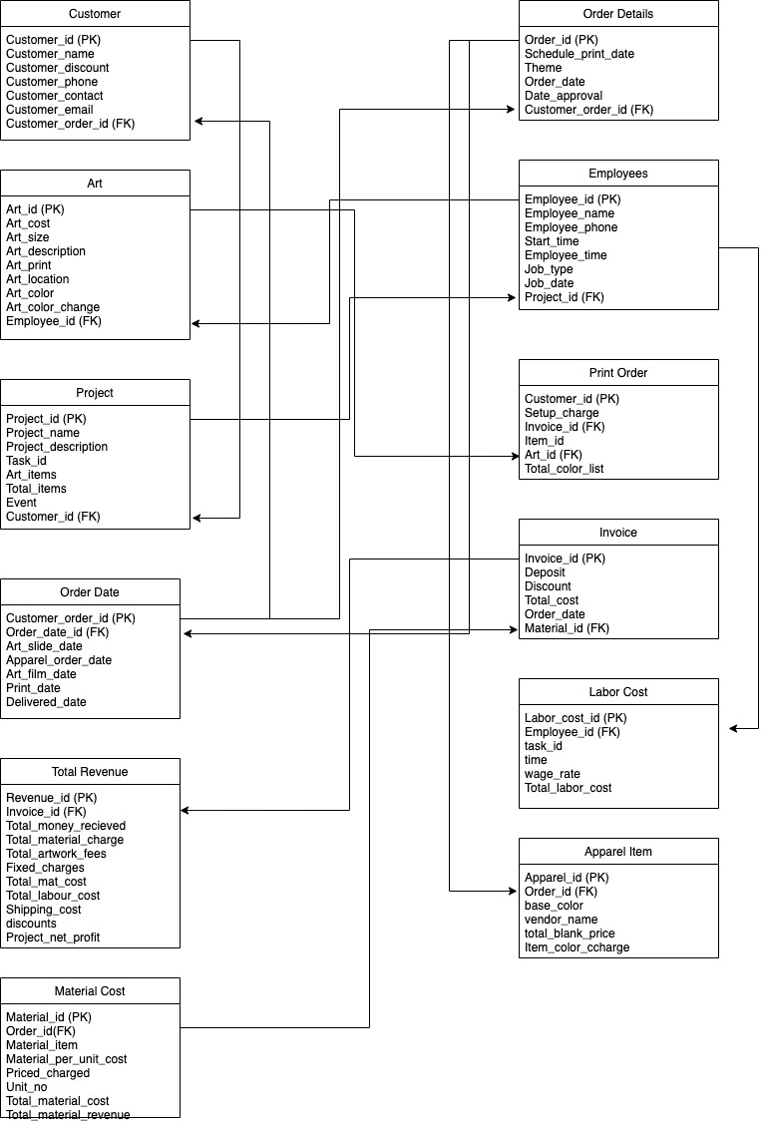

2.2 Functional Requirements (Business functions, Input, and Output Layouts)

Bob wants to gather all of the necessary information and complete the task within the time limit.

Let's explore how much data Bob can glean from diverse photographs.

1. **Figure 1:** Bob needs all the customer information, art specifics, art colors, order dates, printing dates, approval dates, customer event, customer theme, and apparel items. So, if he needs detailed client information, he may use Customer id to retrieve it.
2. **Figure 2:** In this figure, Bob will locate all of the employee information, for which he will require employee id. He can use employee id to determine which employee is working on which assignment or art.

**3. Figure 3:** In this figure, Bob will find all of the customer's print order details. Customer information, associated dates, various costs, apparel/item information, and art information are all included in the specifics.

**4. Figure 4:** Bob will locate all of the project cost analysis reports in this figure. As a result, he can keep track of all profit and loss statements. This graph can extract project information, customer information, material costs, labor costs, total funds received, artwork fees, shipping charges, discounts, and net profit.

2.2.1 Interface Requirements

**Customer**

* Customer_id accepts numeric data entry
* Customer_name accept text data entry
* Customer_contact accept numeric data entry
* Customer_phone accept numeric data entry
* Customer_email accept email data entry
* Customer_discount accepts numeric data entry
* Customer_order_id accepts numeric data entry

**Order_details**

* Customer_order_id accepts numeric data entry
* Order_date accepts data entry
* Date_approval accepts data entry
* Scheduled_print_date accepts data entry
* Theme accepts character entry
* Event accepts character entry
* Apparel_item accepts character entry
* Base_color accepts color entry
* Max_colors accept color entry

**Art**

* Art_id accepts numeric data entry.
* Art_location accepts location entry
* Art_print accept design entry.
* Art_description accepts character only.
* Art_cost accept numeric entry.
* Art_size accept numeric as well as length entry.
* Art_colors accept character entry.
* Art_color_change accepts color entry.
* Employee_id accepts numeric data entry.

**Employee**

* Employee_id accepts numeric data entry
* Employee_name accepts character entry
* Employee_phone accept numeric data entry
* Job_type accept boolean type
* Job_date accept data entry
* Start_time accept time entry
* Employee_work_time accept time entry
* Project_id accept numeric data entry.

**Project**

* Project_id accept numeric data entry
* Project_name accept character entry
* Project_description accept character entry
* Project_task accept character entry
* Event accept character entry
* Art_items accept character entry
* Customer_id accept numeric data entry

**Material Cost**

* Material_id accept numeric data entry
* Material_item accept character entry
* Material_per_unit_cost accept numeric data entry
* Material_qty accept numeric data entry
* Material_cost accept numeric data entry
* Total_material_cost accept numeric data entry
* Material_revenue accept numeric data entry
* Total_material_revenue accept numeric data entry

**Total Revenue**

* Order_id accept numeric data entry
* Total_money_recevied accept numeric data entry
* Total_material_charge accept numeric data entry
* Total_material_cost accept numeric data entry
* Total_artwork_fees accept numeric data entry
* Fixed_charge accept numeric data entry
* Total_labour_cost accept numeric data entry
* Shipping_cost accept numeric data entry
* Project_net_profit accept numeric data entry

**Print order**

* Customer_id accepts numeric data entry
* Setup_charge accepts numeric data entry
* Inovice_id accept numeric data entry
* Item_id accept numeric data entry
* Art_id accept numeric data entry
* Total_color_list accepts character data

**Order date**

* Customer_id accepts numeric data entry
* Art_slide_date accepts date entry
* Apparel_order_date accept date entry
* Art_film_date accpet date entry
* Print_date accpet date entry
* Delivered_date accpet date entry

**Invoice**

* Invoice_id accept numeric data entry
* Deposit_amount accept numeric data entry
* Discount_amount accept numeric data entry
* Total_cost accept numeric data entry
* Order_date accept date entry
* Due_date accept date entry

**labour cost**

* Employee_id accept numeric data entry
* Employee_name accept character data entry
* Task_id accept numeric data
* Time accept time data
* Wage_rate accept numeric data
* Labour_cost accept numeric data
* Total_labour_cost accept numeric data entry

2.2.2 Business Requirements

# The following are the business requirements for this project that must be met:

# • Employees have full access to and control over all database data.

# • Customers can submit information about their clothing, artwork, and theme via the website's form.

# • All customer and staff information can be created, viewed, updated, and deleted by BOB.

# • All data must be stored in databases.

# • All artwork orders, print orders, personnel work logs, and project cost analysis data can be kept in BOB.

# • Each employee's worklogs and artwork would be updated, and they'd be assigned to their project chevalier.

# **3.0 Methodology**

The following topics are intended to serve as a jumping off point:

In this section, you may include the following items.

DDLs are used to create databases and tables.

2. Tools, strategies, and procedures for projects

3. System architecture and programming languages utilized, as well as hardware and software requirements.

4. Data Model and Data Requirements: Detailed data inputs and reporting information.

5. Create a list of all application functions, including inputs, outputs, screens, and reports, and organize them by function names. (Use tables to summarize)

6. System configuration and implementation

3.1 DDL Commands

**User Table**

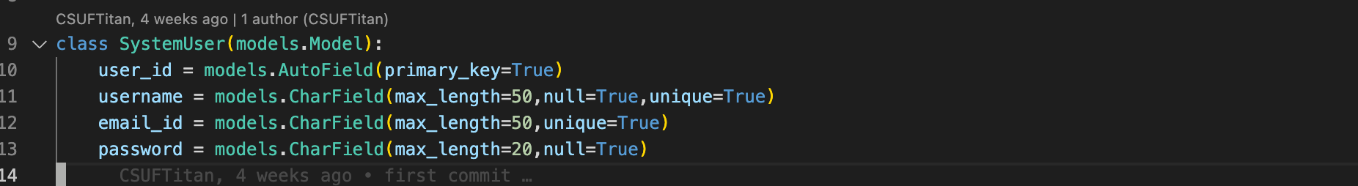

**Artwork Order Table**

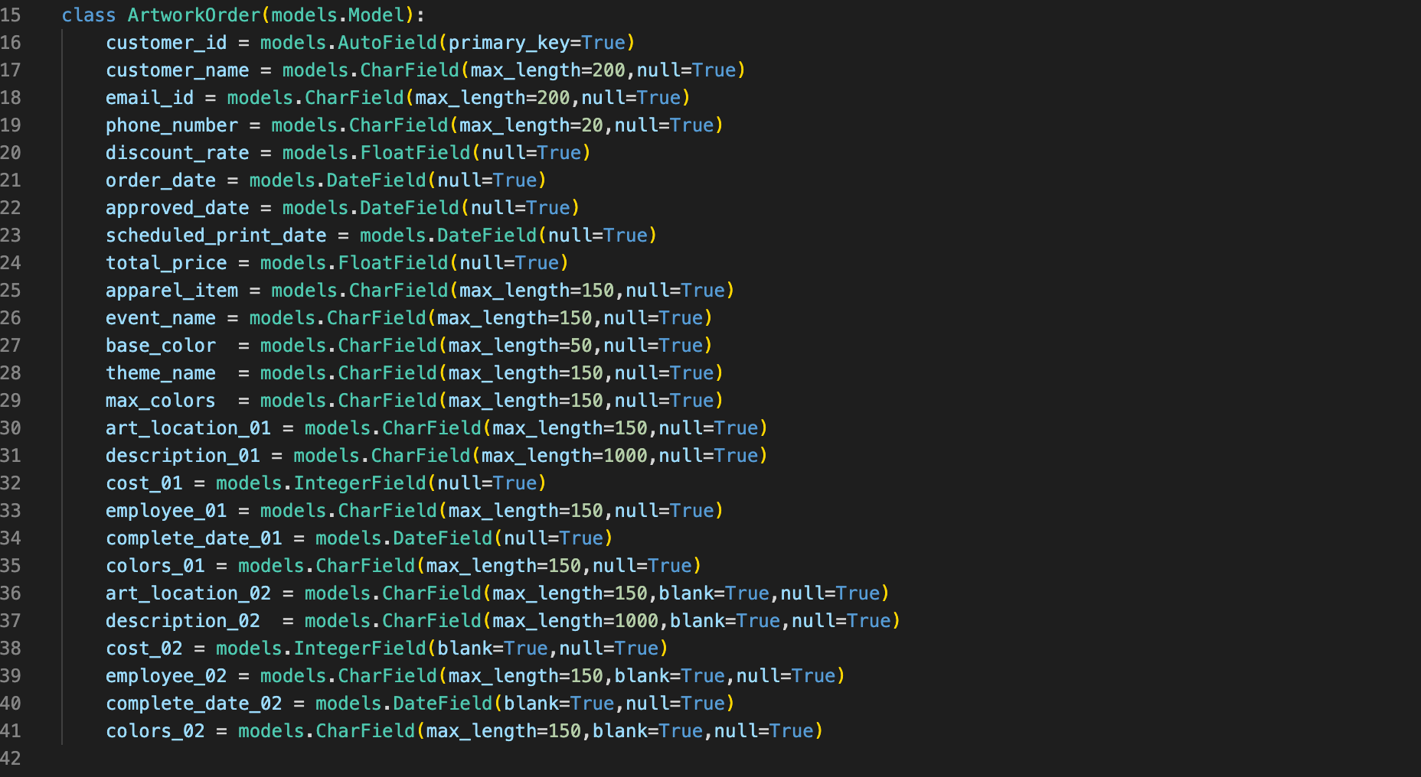

**Employee Work Details Table**

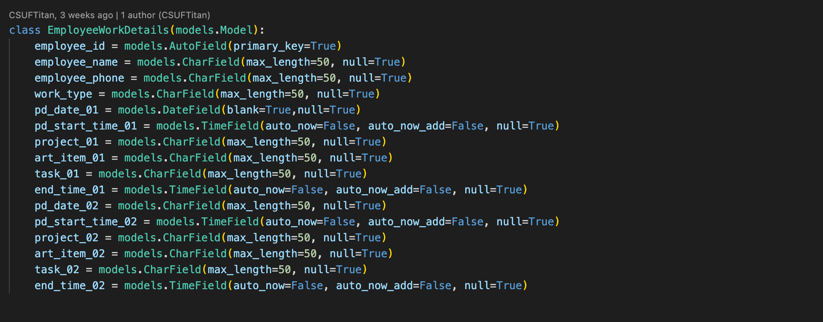

**Print Order Table**

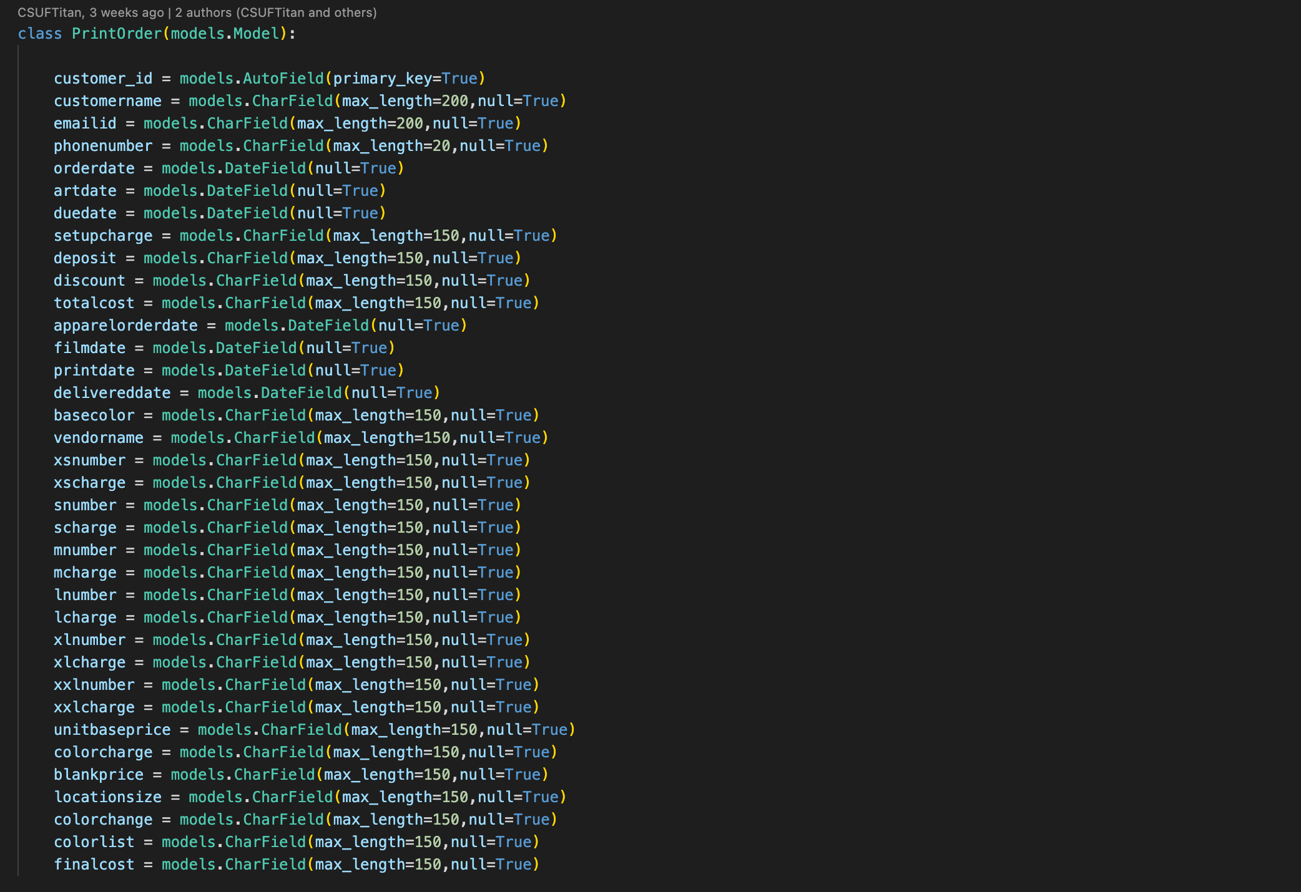

**Project Cost Analysis Table**

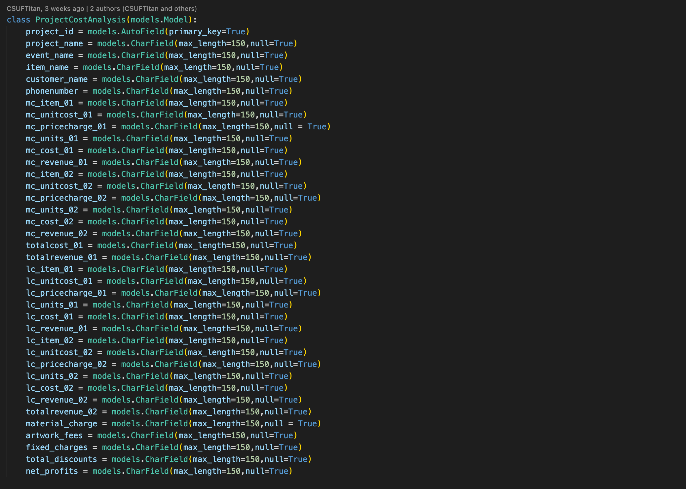

3.2 Software Stack

3.2.1 Database:

* SQlite

3.2.2 Programming Language:

* **Backend**: Python3
* **Frontend**: HTML, CSS, Bootstrap, JavaScript,SCSS

3.2.3 Software:

* Visual Studio Code Editor
* SQlite Management Studio

**3.2.4 Hardware**:

* Operating System: Windows 11

# **4.0 Results and Discussion**

The results of the application are objectively described and analyzed in this chapter (outputs screens and reports). Use only the charts, tables, and figures that are necessary to support the narrative. Complete reports might be included as appendices.

The following themes are meant to serve as a starting point:

• Process screens that are functional.

• Query Reports with detailed explanations

• A detailed explanation of the screen results or reports.

4.1 Screens

**Login Screen**

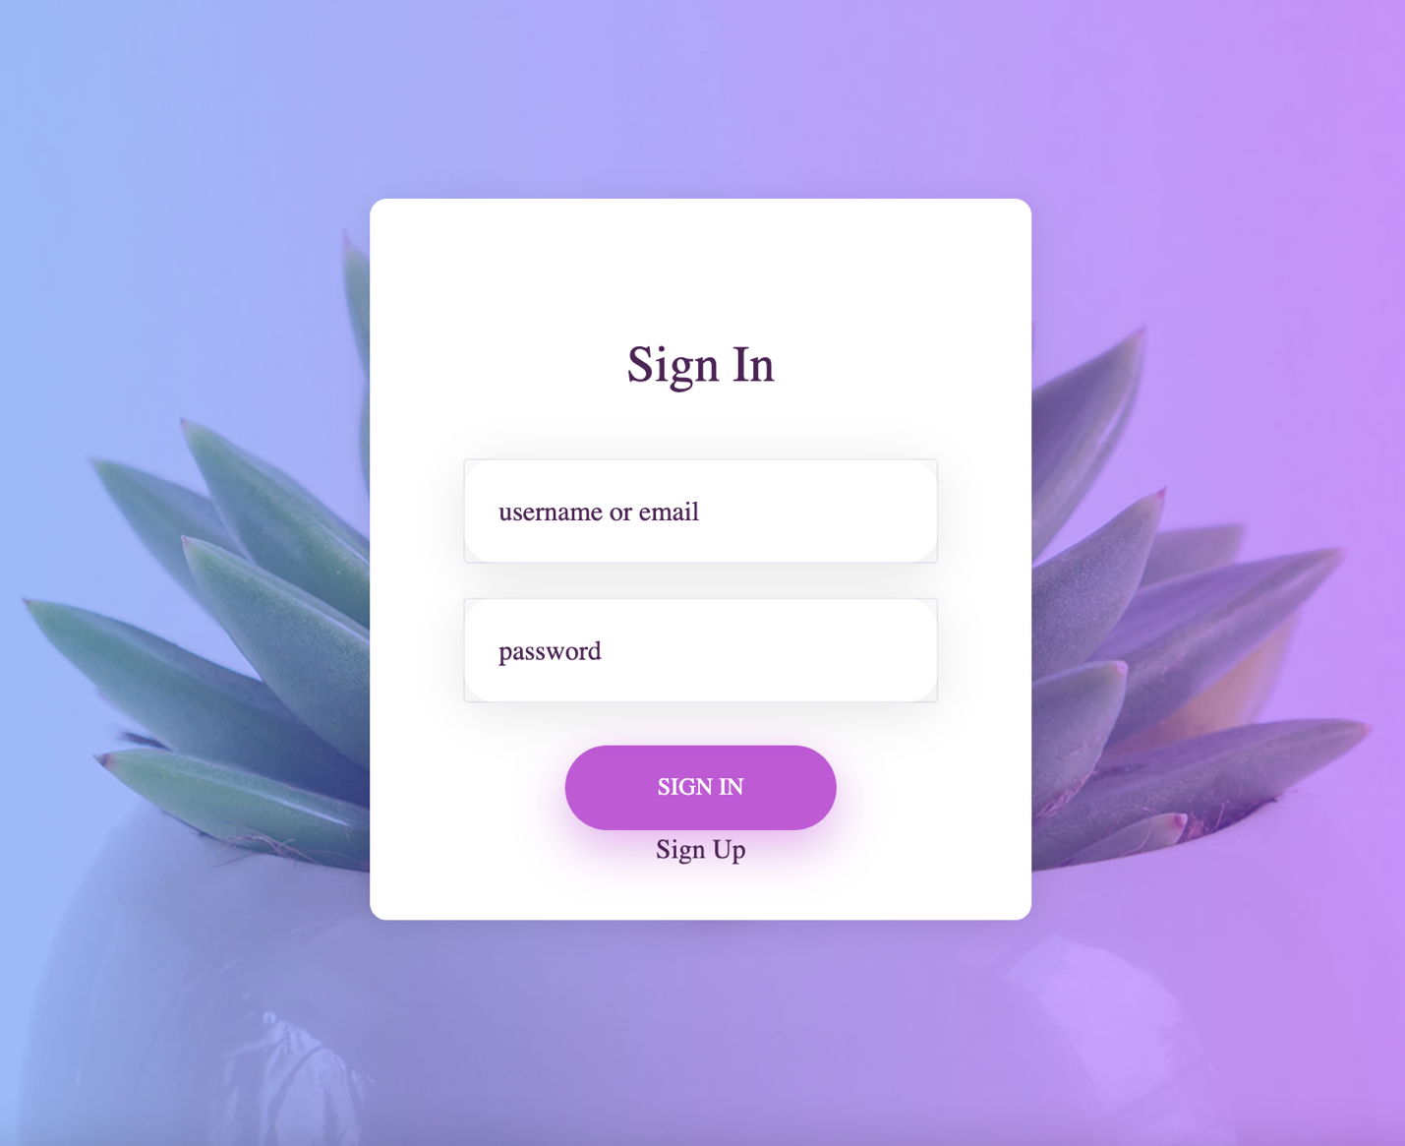

**Sign Up**

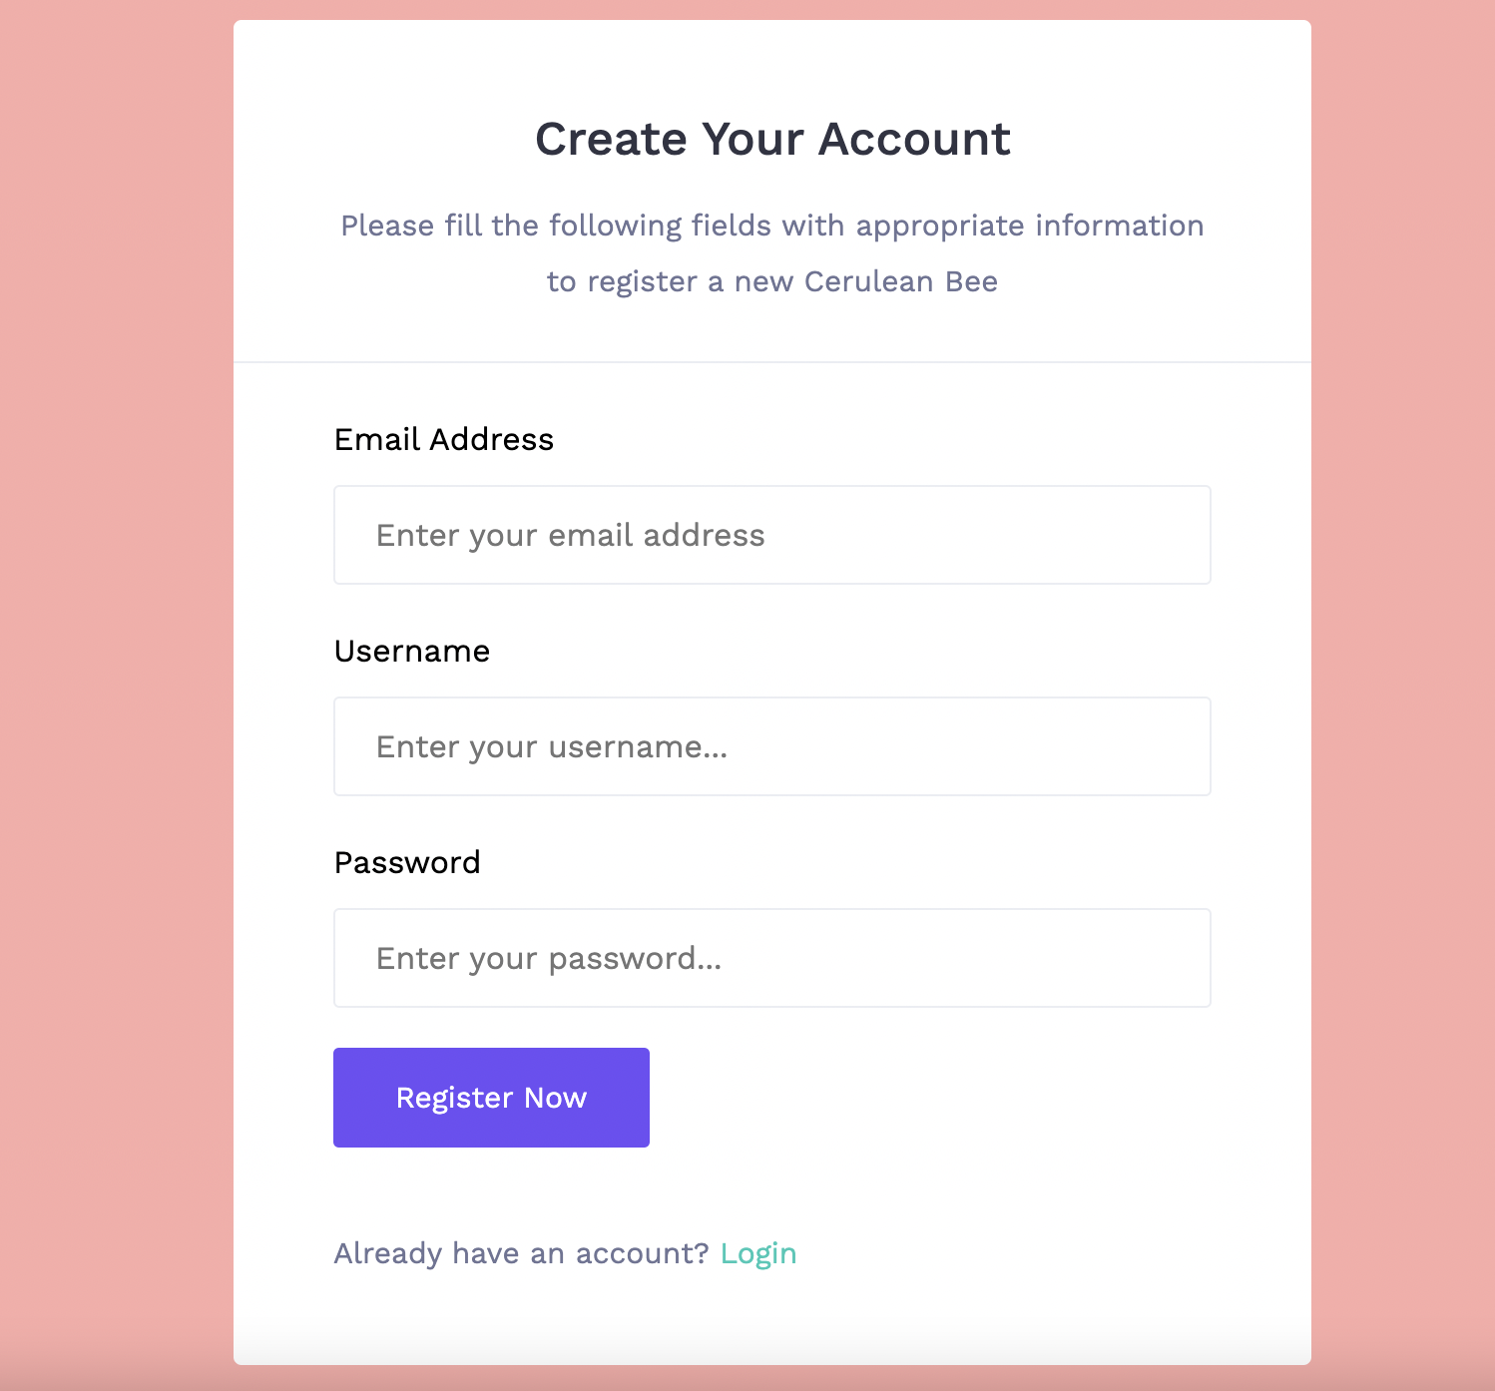

**Dashboard**

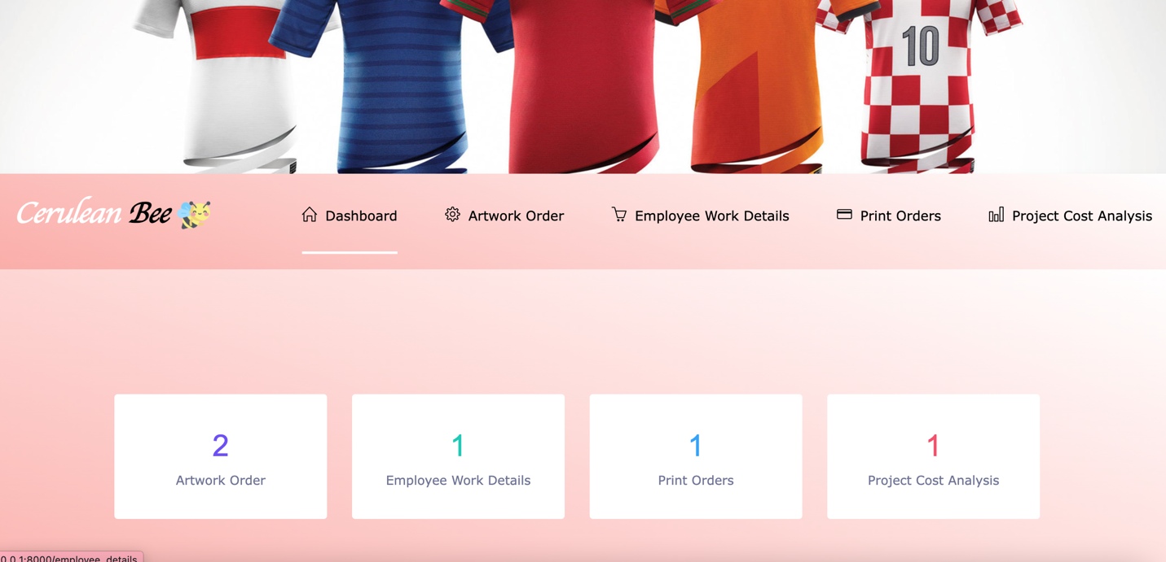

**Artwork Order**

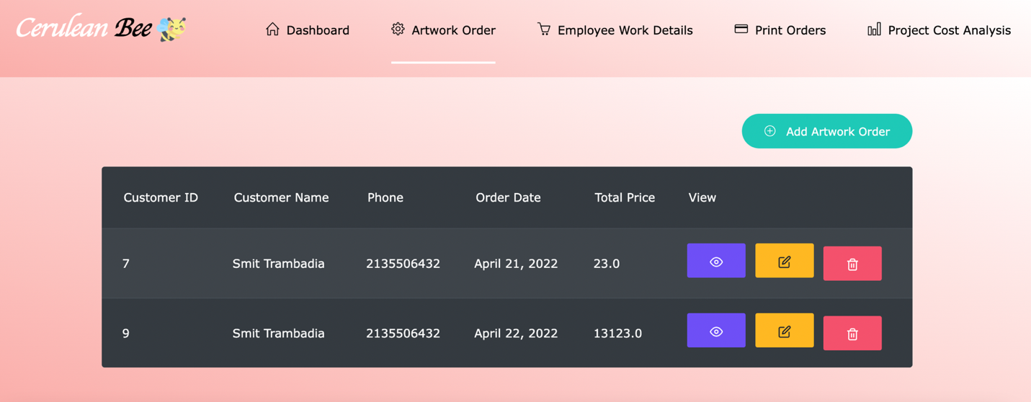

**Add Artwork Order**

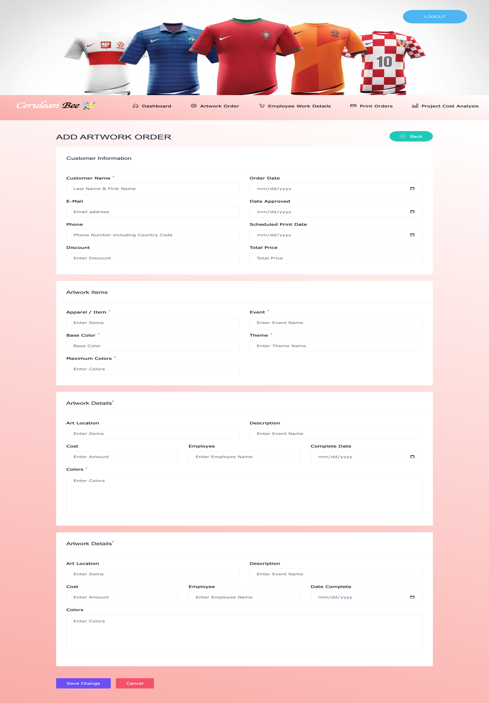

**Employee Work Log**

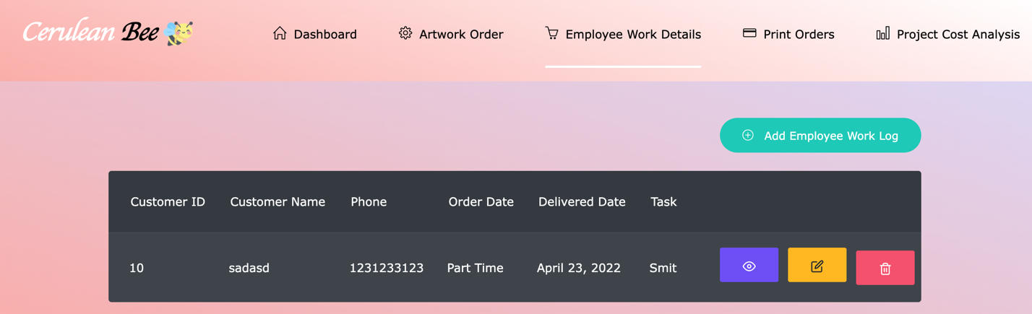

**Add Employee Work Log**

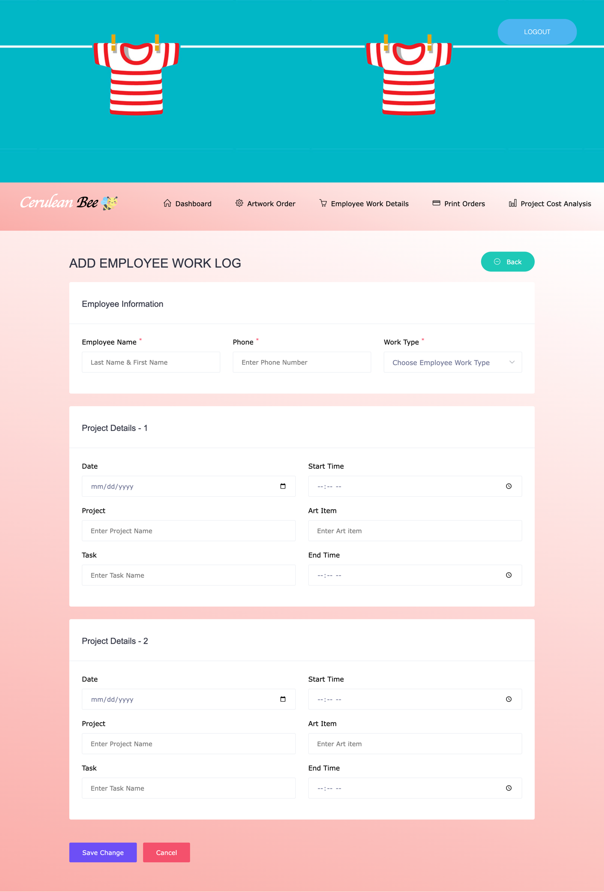

**Print Order**

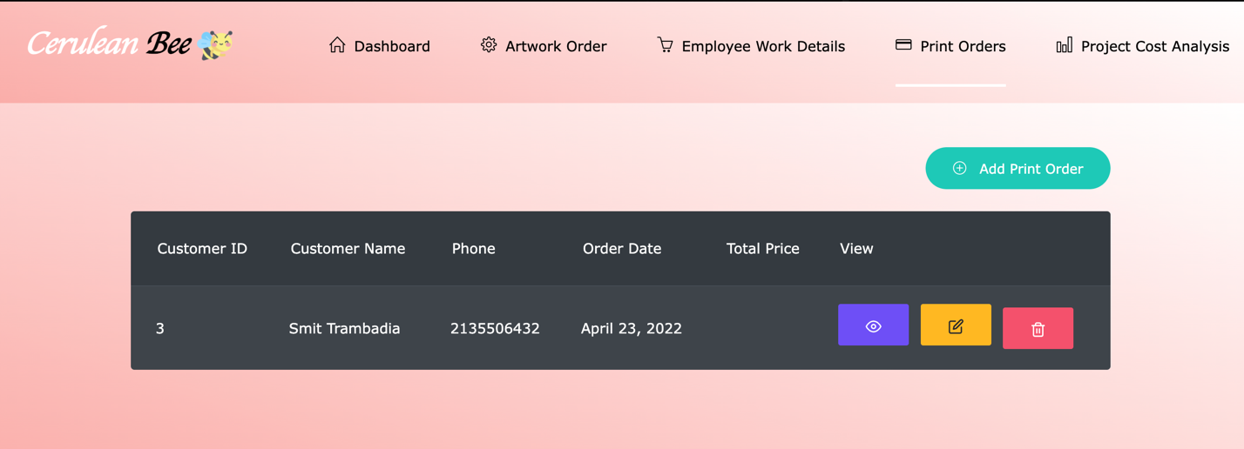

**Add Print Order**

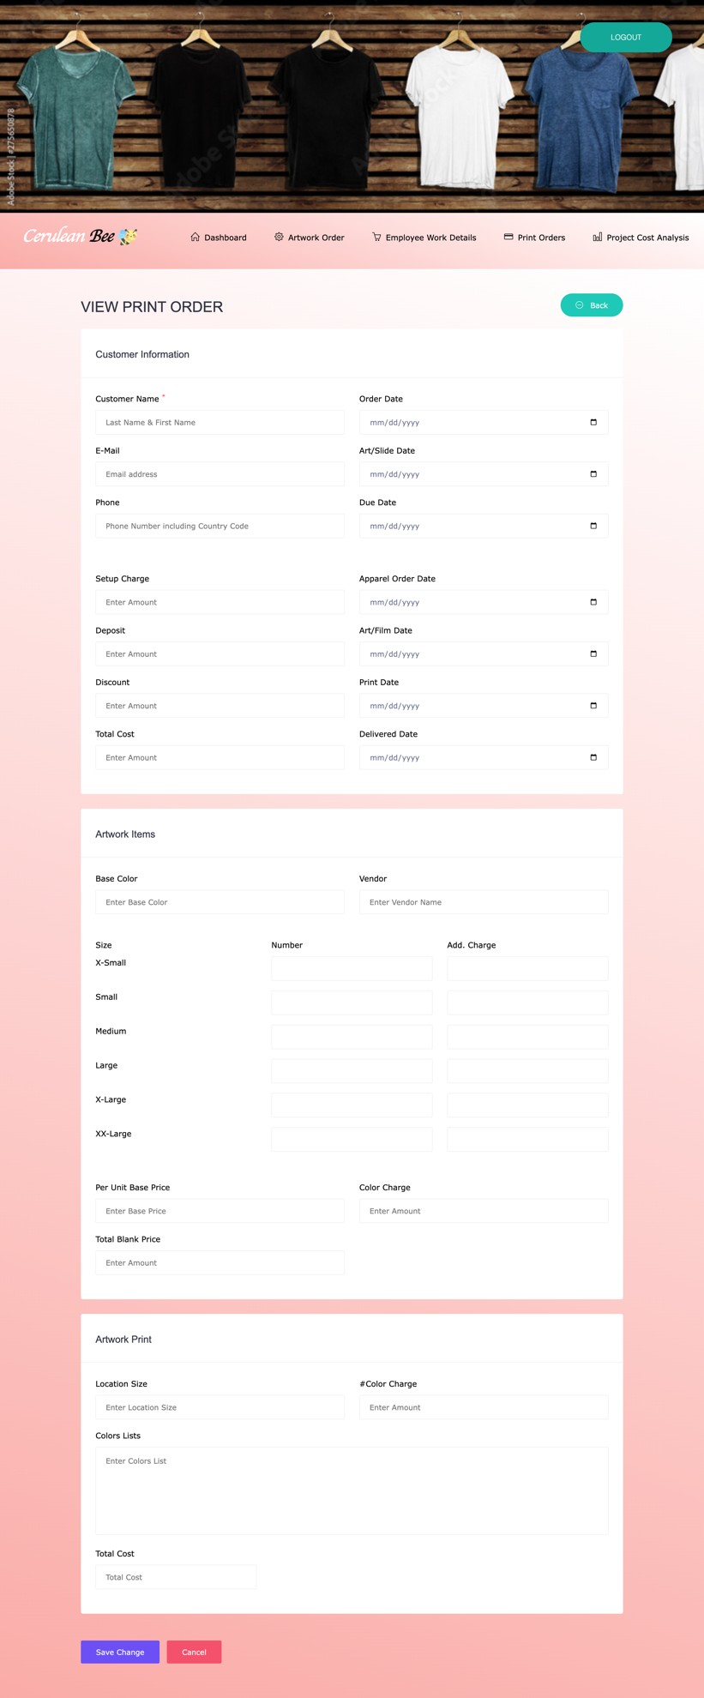

**Project Cost Analysis**

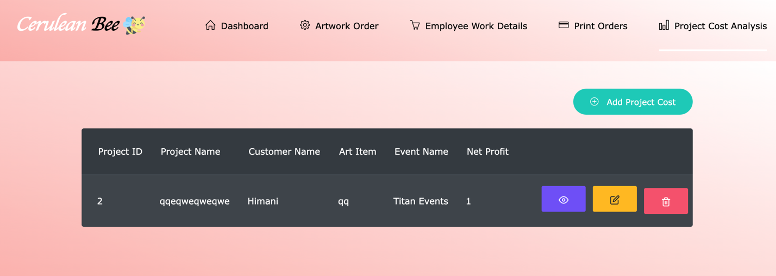

**Add Project Cost Analysis**

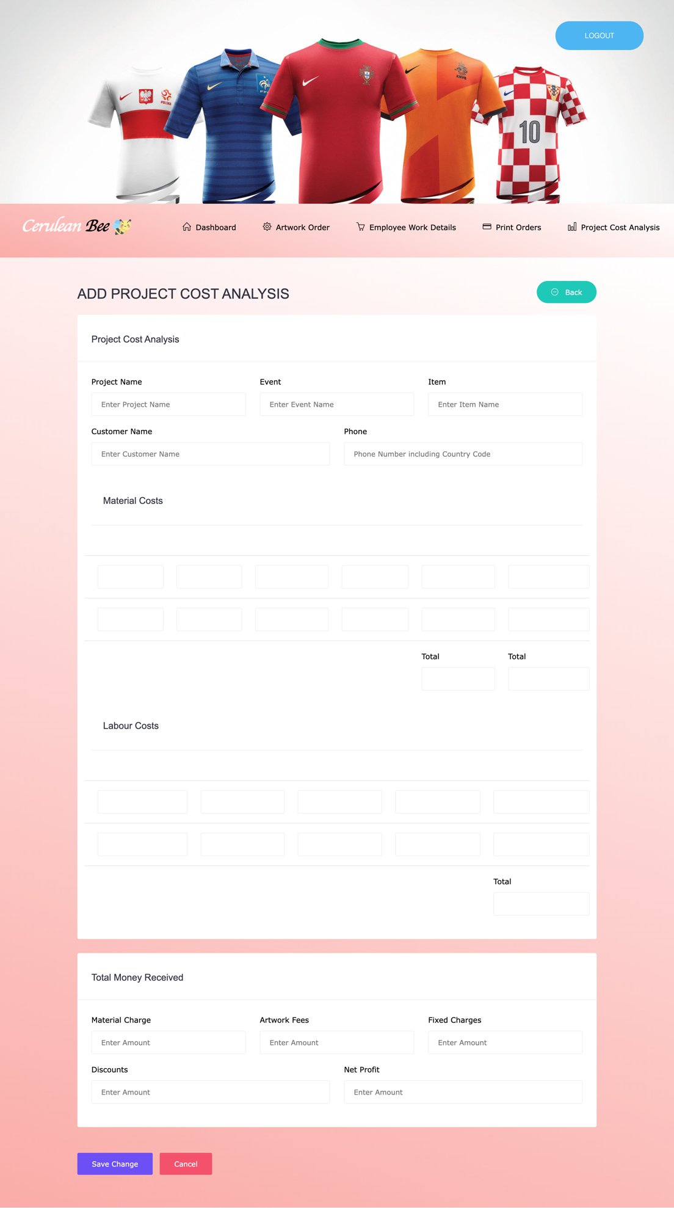

# **5.0 Conclusions**

5.1 Significance

• Practical database and web application design experience

5.2 Learnings from this project

• Carrying out CRUD operations

• Database concept applied to real-world things.

• Front-end development tools are used

• We know how to normalize large databases, how to make them redundant, and how to increase their efficiency.

• Also gained knowledge with programming languages such as HTML, CSS, Bootstrap, and PHP.

5.3 Future Work

• In the future, we will be able to construct 3D trials on the system itself utilizing AI and Computer Vision.

• We can pre-define some things in the database so that adding them to an invoice is simple.

• We can improve the system's user interaction.

• We can create a dynamic data collection that includes the values of various variants of the same product.

• Using a data base, we may create an analysis system to determine what types of customers visit BOB. (What are their tastes, dislikes, sizes, and so on...)

# **6.0 Appendices**

**Cerulean/**

**Static/**

**Css/**

bootstrap

animate.css

font-awesome.min.css

jquery-ui.css

line-awesome.min.css

magnific-popup.min.css

main.css

select2.min.css

simple-line-icons.css

slick.css

trumbowyg.min.css

util.css

venobox.css

**Fonts/**

fontawesome-webfont.eot

fontawesome-webfont.ttf

fontawesome-webfont.woff

fontawesome-webfont.woff2

line-awesome.ttf

line-awesome.woff

line-awesome.woff2

simple-line-icons.eot

simple-line-icons.ttf

simple-line-icons.woff

simple-line-icons.woff2

**Js/**

chart.bundle.min.js

grid.min.js

jquery-ui.min.js

jquery.barrating.min.js

jquery.countdown.min.js

jquery.counterup.min.js

main.js

map-custom.js

owl-carousel.js

owl-carousel.min.js

select2.full.min.js

slick.min.js

tether.min.js

trumbowyg.min.js

venobox.min.js

waypoints.min.js

**Templates/**

add_artwork_order.html

add_employee_work.html

add_print_order.html

add_project_cost_analysis.html

artwork_order.html

edit_artwork_order.html

edit_emplpoyee_work.html

edit_print_order.html

edit_project_cost_analysis.html

employee_details.html

header.html

headermain.html

home.html

index.html

print_order.html

project_cost_analysis.html

signup.html

view_details_artwork.html

view_employee_work.html

view_print_order.html

view_project_cost_analysis.html

__init__.py

admin.py

apps.py

models.py

tests.py

views.py

**cerulean_bee/**

__init__.py

asgi.py

settings.py

urls.py

wsgi.py

db.sqlite3

manage.py